Project Planning Phase
Project Planning Template (Product Backlog, Sprint Planning, Stories, Story points)

Date | 30 September 2026
Team ID | SWTID-2026-1437
Project Name | AI WeatherWise API
Maximum Marks | 5 Marks

Product Backlog, Sprint Schedule, and Estimation (4 Marks)
Use the below template to create product backlog and sprint schedule
Sprint | Functional Requirement (Epic) | User Story Number | User Story / Task | Story Points | Priority | Team Members
Sprint-1 | Registration | USN-1 | As a user, I can register for the application by entering my name, email and password. | 3 | High | Backend Developer
Sprint-1 |  | USN-2 | As a user, I receive a clear error if I try to register with an email that already exists. | 2 | High | Backend Developer
Sprint-1 | Login | USN-3 | As a user, I can log in by entering my email and password and receive an access token. | 3 | High | Backend Developer
Sprint-1 |  | USN-4 | As a user, I am told when my login credentials are wrong. | 2 | High | Backend Developer
Sprint-2 | Authentication | USN-5 | As a user, I can access protected routes only with a valid token. | 3 | High | Backend Developer
Sprint-2 | User Profile | USN-6 | As an authenticated user, I can view my profile details. | 3 | High | Backend Developer
Sprint-2 | Weather Information | USN-7 | As a user, I can get the current weather information for a city. | 5 | High | API Integration Developer
Sprint-3 |  | USN-8 | As a user, I get a proper error message when I search for an invalid city. | 2 | Medium | API Integration Developer
Sprint-3 | AI Weather Insights | USN-9 | As a user, I can get AI-based insights and suggestions for the weather of a city. | 5 | High | AI Integration Developer
Sprint-3 |  | USN-10 | As a user, I get a helpful message if the AI service is unavailable. | 2 | Medium | AI Integration Developer
Sprint-3 | Database Operations | USN-11 | As a system, user data is stored and retrieved reliably from MongoDB. | 3 | High | Database Developer
Sprint-4 | Error Handling & Validation | USN-12 | As a user, I get consistent validation errors for missing or invalid input. | 3 | Medium | Backend Developer
Sprint-4 | Testing | USN-13 | As a tester, I can verify all API responses through UAT test cases. | 3 | High | Tester
Sprint-4 | Documentation | USN-14 | As a developer, I can read the API usage documentation. | 2 | Low | Team
Sprint-4 | Deployment | USN-15 | As an administrator, I can run the API with environment-based configuration. | 2 | Medium | Team

Project Tracker, Velocity & Burndown Chart: (4 Marks)
Sprint | Total Story Points | Duration | Sprint Start Date | Sprint End Date (Planned) | Story Points Completed (as on Planned End Date) | Sprint Release Date (Actual)
Sprint-1 | 10 | 6 Days | 01 Sep 2026 | 06 Sep 2026 | 10 | 06 Sep 2026
Sprint-2 | 11 | 6 Days | 08 Sep 2026 | 13 Sep 2026 | 11 | 13 Sep 2026
Sprint-3 | 12 | 6 Days | 15 Sep 2026 | 20 Sep 2026 | 12 | 20 Sep 2026
Sprint-4 | 10 | 6 Days | 22 Sep 2026 | 27 Sep 2026 | 10 | 27 Sep 2026

Velocity:
Imagine we have a 10-day sprint duration, and the velocity of the team is 20 (points per sprint). Let’s calculate the team’s average velocity (AV) per iteration unit (story points per day)

For AI WeatherWise API: sprint duration = 6 days, velocity = 10.75 story points per sprint on average (43 story points over 4 sprints, 24 days). Average velocity (AV) = total story points / total days = 43 / 24 = 1.79 story points per day.

Burndown Chart:
A burn down chart is a graphical representation of work left to do versus time. It is often used in agile software development methodologies such as Scrum. However, burn down charts can be applied to any project containing measurable progress over time.
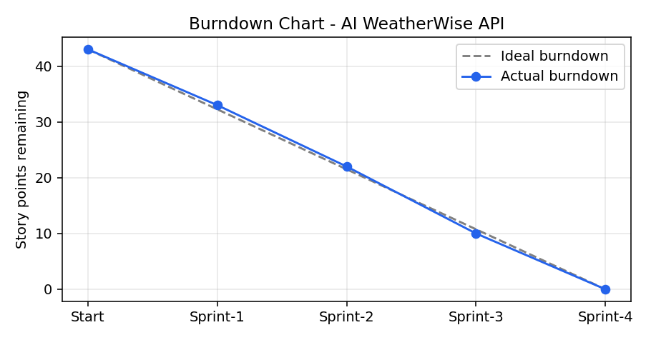

https://www.visual-paradigm.com/scrum/scrum-burndown-chart/
https://www.atlassian.com/agile/tutorials/burndown-charts

Reference:
https://www.atlassian.com/agile/project-management
https://www.atlassian.com/agile/tutorials/how-to-do-scrum-with-jira-software
https://www.atlassian.com/agile/tutorials/epics
https://www.atlassian.com/agile/tutorials/sprints
https://www.atlassian.com/agile/project-management/estimation
https://www.atlassian.com/agile/tutorials/burndown-charts

